Task 6: Charts and Data Visualization Report

1. Revenue by Service (Bar Chart)
This chart shows the total budget generated by each service in the dataset. It helps compare the revenue contribution of different services. Data Analytics generated the highest budget, while SEO Services contributed the lowest budget among all services.

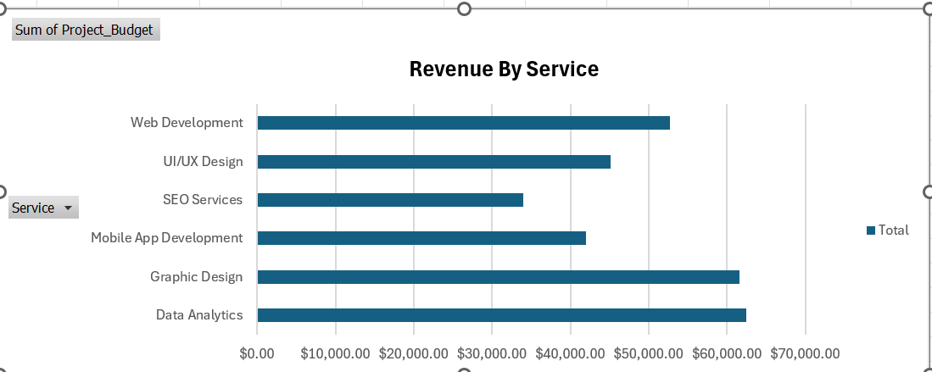

2. Clients by City (Column Chart)
This chart shows the number of clients from different cities. It helps understand where most clients are located. Karachi has the highest number of clients, while some cities have fewer client records.
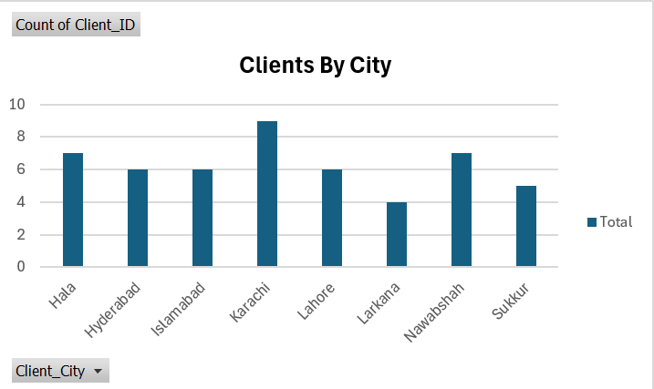
3. Project Status Distribution (Pie Chart)
This chart represents the distribution of projects according to their status. It provides a quick overview of completed, pending, and ongoing projects. The chart makes it easy to compare project progress visually.

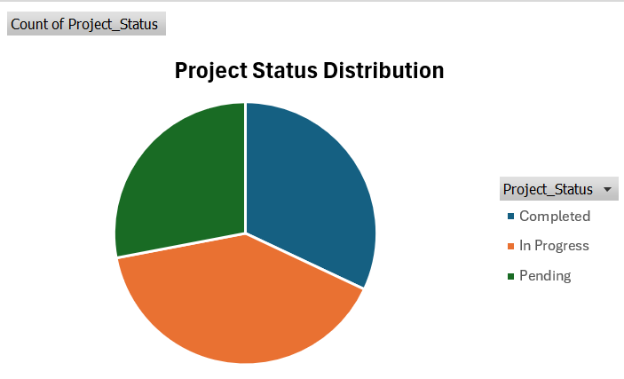

4. Projects by Date (Line Chart)
This chart shows project activity over different dates. It helps identify trends and patterns in project starts. The line chart provides a clear view of how projects are distributed over time.
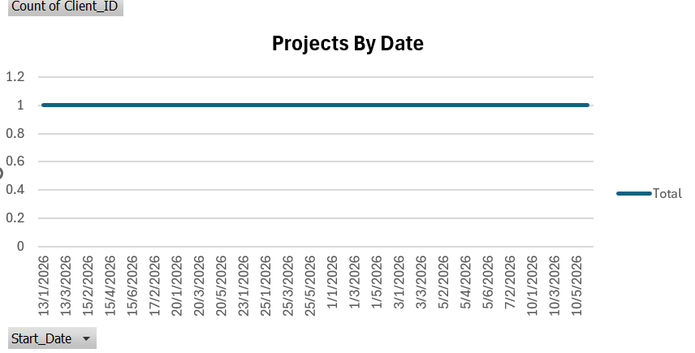
5. Payment Status Summary (Donut Chart)
This chart shows the payment status of all projects in the dataset. It compares paid and pending payments in a simple visual format. This helps track the overall payment performance of the business.
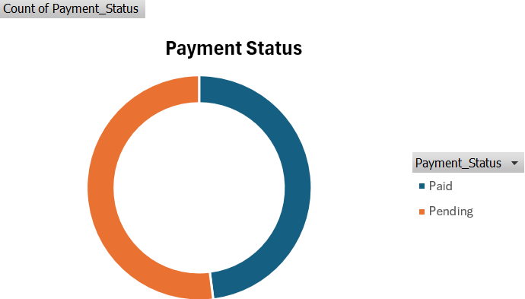

6. Budget and Rating by Service (Combo Chart)
This chart compares project budget and client ratings for each service. It helps analyze both financial performance and customer satisfaction at the same time. Different services show different levels of budget contribution and client ratings.
